**Document Understanding Cost:**

**(OCR+Storage+Pre-Trained Model Usage)** / **( OCR+Storage+Custom-Model Training+Custom-Model Usage)**

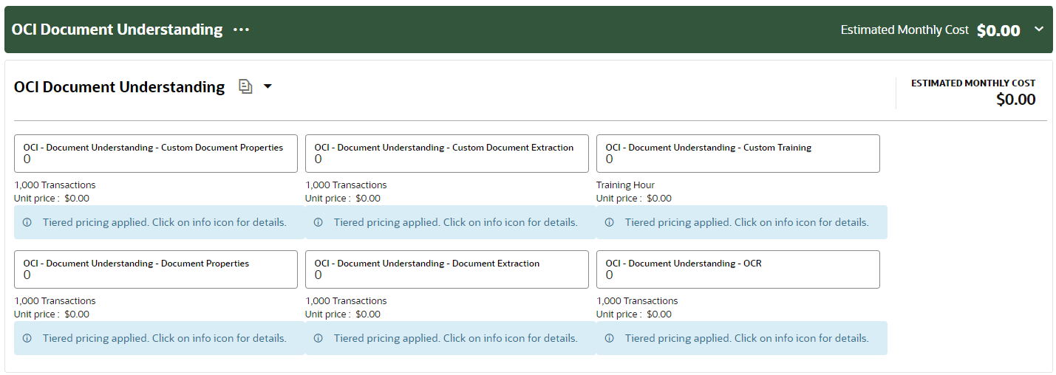

**10 *2 = 20/1000=0.02**

**1 page = 1 transaction**

**Document -> Pages=Transactions**

**10 Documents = 2 pages each = 20 pages (20 Transactions)**

**1 Page = 0.01$**

**10 = 0.1$**

**100 = 1$**

**1000 = 10$**

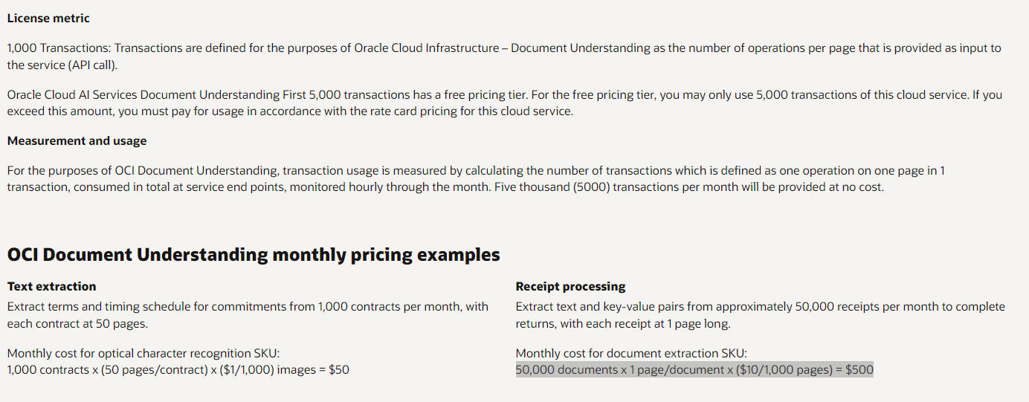

**Object Storage:**

**UI: (Compute+Database+OIC+VBCS+Fusion/EBS)**

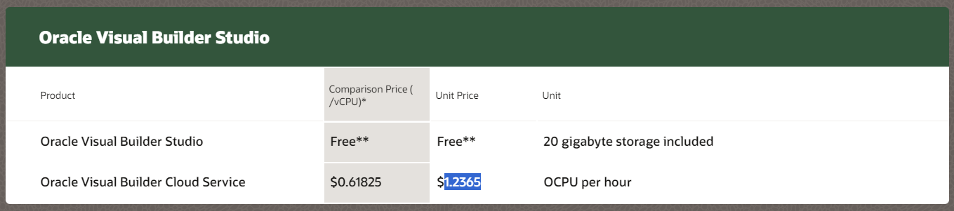

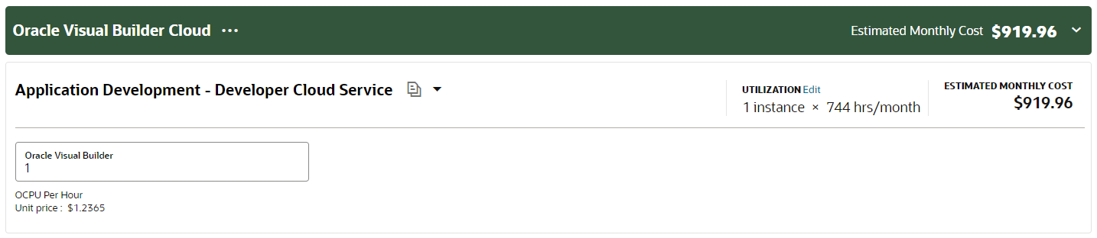

**Pre-trained key-value:**

Key Value feature is supported only for receipt, invoice, passport, and driver license document types."

